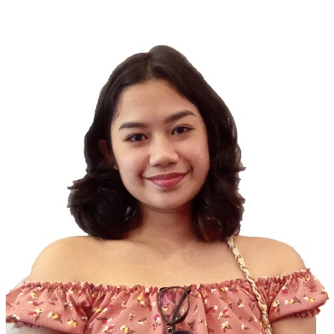

Hanna Princess Rodrigo

# Professional Goals

I eagerly aim to attain a virtual assistant position in this field. And I desire to use all my skills in serving my client that will be worthy and beneficial to them.

# Get in touch!

Mobile:

0975-834-6147

Email:

[hannaprincessrodrigo25@gmail.com](mailto:hannaprincessrodrigo25@gmail.com)

Address:

Purok-9, Brgy. Sumpong, Malaybalay City, Bukidnon, 8700

# Work Experience

Barista / Cashier

Amanda and Annabelle Cakes and Pastries | June 2019 - May 2020

* Manage the product displays of the store.
* Entertain and make drinks for customers.

# Academic History

Bukidnon State University

Bachelor of Science in Entertainment and Multimedia Computing Major in Digital Animation – Third Year SY 2021-2022

* Dean’s Lister | Every semester except 1st year 2nd semester

Bukidnon National High School

Junior High

Senior High School Graduate SY 2018-2019

– NCII Cookery passer

Sarayan High School |First Year

Junior High School

- Science News Writer

- News Editor

* Public Speaking
* Communication
* Computer Literate
* English Speaking Skill
* Microsoft Office Software
* Video Editing

Specializations

Languages Spoken

**English Tagalog**

**Bisaya**